**Project Name:** Hospital Drug Information System.

**Student Name:** Muhammad Daniyal.

**Roll-Number:** BSIT-LD-17-46.

**Supervisor Name:** Kamran Qadir.

**Department Name:** BZUSub-Campus Lodhran.

**Session:** 2017to 2021.

**Abstract**

Big problem in 20s is covid-19 so I want to create online system that covers patients without appearing on clinic. Some cities people reported that doctors not attending patients properly because they afraid covid-19. This system overcomes those problems. This system provides facility to patients that get appointments and doctors check patients online. Drug information system refers to facility specially set aside for, and specializing in the provision of drug information and related issues. The purpose of drug information center is to provide authentic individual, accurate, relevant and unbiased drug information to the consumers and healthcare professionals. Provide information about use of drug and side effects. Drug information refers to current critically examined relevant data about drugs and drug use in a given patient in a particular situation. Large health centers usually decentralize their services to small self-sufficient sub-centers of care delivery. These small centers are part of an extensive network of practitioners who are connected. The drug information services of independent clinical pharmacists in a health center could be fragmented. The pharmacy information system is a sub-system of the hospital information system which is designed to assist pharmacists in safely managing the medication process. Drug information system is a center pillar of the word because health is more important for human and every living. Central aim of this project is to provide information about our medicines and there use and side effects.

**Introduction**

This is drug information system that covers patients online all over the world. This system provides information about medicine. Patients directly communicate with us. They get appointment from our system and system provides information to doctor about that appointment. Doctor attends that patient using any video call app or voice call and reports submitted from email of doctor. Doctor attend patient and prescription send to our assistant that provide all information to pharmacy and medicine send to the patient through TCS or any courier service that is easily provided and also patient system online. There are developing multiple systems and connect to the main system. Main system is a central system that handle by owner. Ability provides to the owner that access main system and also sub systems. Other side we use a system that only consist on production. That system gets raw material and control production of medicine. We also can say production is pharmaceutical company that produce medicine and send to the stock. Stock is also a sub system where medicine stored. There is a person that control all stock and get order and send medicine receive payment and place order to the production when medicine supply increase. Now stock maintainer sends medicine to the pharmacy that maintain patients it meant pharmacist provide medicine physically or courier service. There is also a sub system that control hospital and doctors. We can say there is a Hospital Drug Information System. There is main system other systems connected with that system. There are doctors and nurses and other staff that want for hospital.

**Background**

I develop a complete system that control drugs all over the world. This system implement as a web application that execute on browsers. I am using multiple technologies to be a successful system. I am using MERN stack that developed high resolution web applications. MERN stands for Mongo database, Express JS, React JS and Node JS. Mongo database is database that use to store information. It is easy to use and easy to understand. Express is a framework of node JS that use to code back end of web application. This execute server side and difficult to understand. Node JS is a library that use to back end code or server side code. React JS is a library that use to code front end or client side. Node.js, Express JS and React JS are libraries of JavaScript that use develop responsive web applications and fast in execution. There I am using Bootstrap that use to develop responsive designs. There is predefine classes that simply use. Some designs we want customize then we use CSS for custom design. HTML tag use for content writing on web application page. We can say I am using HTML, CSS, JavaScript, Bootstrap, React JS, Node JS, Express JS, Mongo database, some packages and dependencies. This project became world more advance and our lives were made easier. I am using mongo compass for store data. It is use on local machine. Visual studio for coding both side meant backend (server side) and frontend (client side). All my project source code uploads on Github. This is responsive web application with responsive design. This is health domain and complete medical system that apply using web technologies.

**Implementation**/**Design**

Now I implement my project using diagrams that is important point that provide interface between user and programmer. Design understandable for user(or client) and developer(coder or programmer). Now we start project modeling. There is five types of diagrams that use to explain complete project. Use case diagram, sequence diagram, activity diagram, class diagram and state diagram.

**Component diagram**

Component diagram is showing our system components or sub-systems. Every system has some sub-systems that collectively develop a complete system.

Online drug management system

Online drug management system is a main system that uses to manage drug digitally, make payments, appointments and so on.

There is some sub-systems of online drug management system.

1. Online sub-system: it is complete online system that uses to maintain drug digitally. That system allow patient to access and place orders anywhere in the word. That system is part of our main systems.
2. Production sub-system: it is also a sub-system that use in production. How much medicine in stock and how much prepare and so on.
3. Stock sub-system: There is sub-system that use for store medicine. There is complete information about medicine demand, supply and amount.

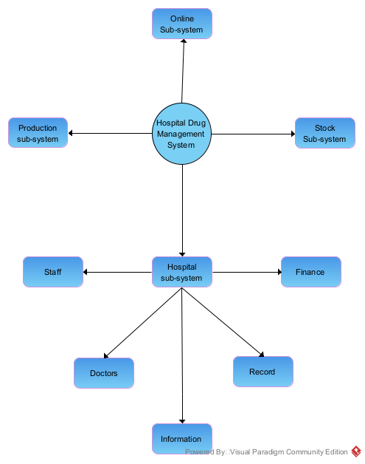

1. Hospital sub-system: There is complete system that is manage medicine in hospital and also patients came there.

* Staff: That is sub-system of hospital in this system manage complete staff of hospital.
* Finance: That is also a sub-system of hospital. There is manage budget and payments of hospitals
* Record: There is also a sub-system that use to manage all records of hospital.
* Information: There is a sub-system that is use to provide information because information have many types.

**Use case diagram**

**System Admin:**

This project is responsible for delivery of best quality of drug. Setting a following standard for operational excellence. Hire and retain qualified staff. Implement clinical procedure and policy. Safeguard required compliance with state and federal regulations as well as hospital policy. Develop a relationship with outside organizations, including the medical community, referring physicians, and the media. Deliver strong financial performance. Admin access system and bear profit and loss.

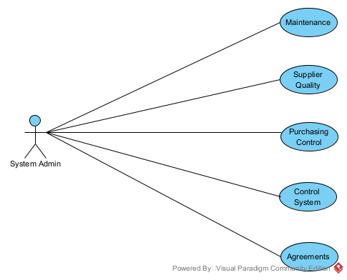

**Maintenance:**

Admin manage complete system because he/she is owner of system and check and balance everything .admin also bear profit and loss.

**Supplier Quality:** Admin also check quality of drug. It is very important because that use for human health. If there is any problem in drug then it can be danger.

**Purchasing Control:** Purchasing control is also important if raw material price increase then also drug price increase. Otherwise it can be result is loss.

**Control System:** It is control complete system and manage it resources.

**Agreements:** there are some agreements that is private, public and governments. Owner follows those agreements.

**Online drug management system**

**Manager:**

Manager is a leader that manage or control complete system and responsible of complete work. He/she take decisions start working of those decisions. He/she decide that Witch Company provides medicine to patient or pharmacy. He/she also consider price and effect of drug. He/she also provide detail or report to the system admin or owner. Manage doctors and hire. Check doctors work properly or not and also suspend doctors and staff that not perform well. Manager provide interface between owner and system.

* **Company:** Company can be production area or stock that supplies drugs. Company has a name. Registration number. Physical address. That have laborers, suppliers, transport system, finance management system, accountant, information provider, dealer etc. all the people report to manager and manager report to admin.
* **Drug information:** There is blog of information system that provide information of drug .it provide drug description where drug name, drug registration number, restricted food when patient use drug, side effect of drug, age restricted etc. it is also provide information about price. This is dynamic sub system that proved everyone same.
* **Appointment:** Their quest to streamline the organization has traditionally prevented patients from moving comfortably throughout their visits and re-visits. Instead, patients are often placed in long waiting lines while receiving minimal information throughout their stay. A minor measure to overcome this problem is to invest in an appointment system. During the years, I’ve seen numerous improvements among hospitals that allow the patient to book appointments in advance. Below, I have summarized the main benefits of patient appointment systems. Given the current situation with the COVID-19 pandemic, an appointment system allows to spread out patient visits throughout the day to maintain social distancing and avoid crowding. When many patients arrive at the same time, for a drop-in consultation, there is a risk of crowding, which contributes to long wait times. With an appointment system, the non-urgent patients can schedule their consultation in advance. As this eliminates wait times upon arrival, it has a significant impact on the patient experience. Long wait times and minimal information are a burden among many patients. Not knowing when to be served is a stressful factor that harms the patient's experience. With an appointment system, the patient can better plan their day as it eliminates the uncertainty of waiting times.
* **Inform Doctor:** Due to COVID-19, health care providers may increase use of [digital health services](https://www.nia.nih.gov/health/telehealth-what-it-how-prepare-it-covered). You can talk to your health care provider online through video or email, or by phone. If you must visit in person, take precautions to protect yourself and others and follow your health care provider’s instructions.  If you have more than a few items to discuss, put them in order and ask about the most important ones first. Don’t put off the things that are really on your mind until the end of your appointment. Some doctors suggest you put all your [prescription drugs](https://www.nia.nih.gov/health/safe-use-medicines-older-adults), over-the-counter medicines, vitamins, and herbal remedies or [supplements](https://www.nia.nih.gov/health/dietary-supplements) in a bag and bring them with you. Others recommend you [bring a list](https://www.nia.nih.gov/health/tracking-your-medications-worksheet) of everything you take and the dose. You should also take your insurance cards, names and phone numbers of other doctors you see, and your medical records if the doctor doesn’t already have them.
* **Provide Time:** Most doctors schedule appointments in 15-minute segments, and studies show that the average appointment lasts between 18 and 20 minutes. Mix in late patients, no-shows, and a host of other time-wasters, and you'll see why you've always spent more time in the waiting room than talking to the doctor.
* **Add payments:**  patients expect a modern billing and payment experience from their preferred Health System. Easy-to-understand e-bills and print statements. Clear SMS text and email notifications. Communications that consider user preferences. A single, simplified bill across all services. Digital-First Billing facilitates email and text communication first with flexible payment options included, without mailing a paper statement. Patients are engaged through the digital channels they prefer and they receive bills six days faster than they would via mail. The result is a better patient financial experience and faster payments for Health Systems.
* **Report saves in database:** Patient report save in database for record. There is computer base database that use to create from system user or programmer. Computer system has tables save patient data date wise. The Patient List Report lists patients and their contact information. For each patient on the report, the following information appears: name, preferred name, date of birth, status, primary contact, and that contact person's contact information (phone number, email address, and mailing address).

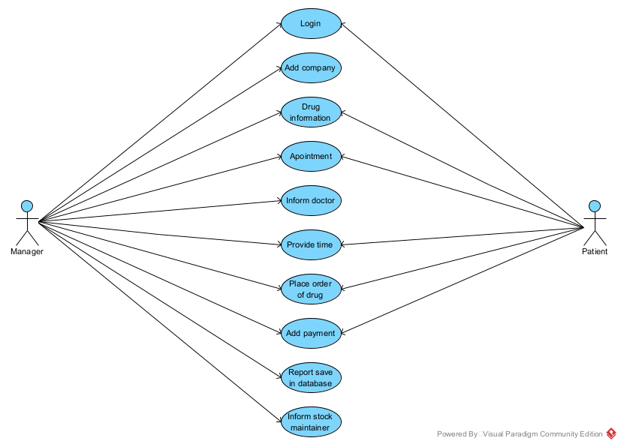

* **Inform stock maintainer:** When drug provided to patient then in pharmacy stock drug is decrease and they make a report that send to the stock maintainer for drug supply. Availability of drug is very important point for Drug management system.

**Patient:**

Patient is a main person for which we create complete system. HMS was introduced to solve the complications coming from managing all the paper works of every patient associated with the various departments of hospitalization with confidentiality. HMS provides the ability to manage all the paperwork in one place, reducing the work of staff in arranging and analyzing the paperwork of the patients. HMS makes it possible to access all the data related to a patient via a system by the means of a few simple clicks. Information like patient history, current illness, doctors involved, tests reports taken, billing information and many more can be made visible to the user. These data will help to connect the dots about the patient, like specific diagnosis, related treatment, and medication.

* **Get time:** it is part of appointment part. In which hospital management system provide time when patient appear in hospital for checkup and treatment. If patient not appear at time then he/she take another time for checkup.
* **Get medicine:** patient get medicine from pharmacy. Patient has prescription that provided to the pharmacist and he/she fined that drug and provides to medicine and tells the use of that medicine to the patient.
* **Pay for medicine:** When pharmacist provides medicine and makes a bill of those medicines. Patient pay for that medicine. There is an accountant that add price in computer system or make paper work for record.

**Drug management system in production**

There is also a sub system that manages production of medicine. There we use raw material to produce medicine. Many laborers work there. When demand of medicine increase then production increase. We hire more people and buy more raw materials to produce more drugs to manage demand of drug. When demand of drug is decrease then decrease production of drug and also raw material. When decrease the demand of medicine then it is problem for production. Because it decreases of profit and profit is main priority of any system, company and business.

**Manager:**

Manager is a leader that manage or control complete system and responsible of complete work. He/she take decisions and start working of those decisions. He/she decide that Witch Company provides medicine to patient or pharmacy. He/she also consider price and effect of drug. He/she also provide detail or report to the system admin or owner. Manage workers and hire. Check workers work properly or not and also suspend workers and staff that not perform well. Manager provide interface between owner and system.

* **Manage drug:** Maintain risk mitigated, reliable, and efficient manufacturing operations. Provide safe, efficacious, and defect-free high quality drug products. Stand in for the consumer (patient) to ensure quality. A drug shall be deemed to be adulterated if the methods used in, or the facilities or controls used for, its manufacture, processing, packing, or holding do not conform to or are not operated or administered in conformity with current good manufacturing practice to assure that such drug. Meets the requirements of this Act as to safety and has the identity and strength, and meets the quality and purity characteristics, which it purports or is represented to possess.
* **Manage order:** Manage order there can be two types of orders. One from stock maintainer that provide detail of supply and demand of drug. Get delivery and specific time. Time is matter there. There is also a accountant that maintain all payments and expenses.
* **Manage delivery:** Manage reliable and secure supply chain. There is transport system that provides transport of drug. Transport dependent on production quantity mean high production maintain with high transport system.
* **Manage stocks:** Stock is main place where we control production. When increase demand of drug then stock is backup for maintain orders. When increase demand of medicine then increase of supply and production of medicine. It is very important part. If we not use stocks then we cannot maintain production and orders.
* **View Service Request:** This is request from stock maintainer or pharmacist. There is two types of service request. If order of drug which mean for production to produce more drug and second is return medicine with description. Side effect or not demanding in market.
* **Send Service Status:** When request is received then as response production send service status mean request accepted or rejected. If request rejected then explain why that request rejected with solid reason.
* **Collect payments:** Payments depends on roles of company or production. Some companies get payment before delivering drug and some companies get after delivering drug. Some have role to half payment before delivering and half after.
* **Service request:** This service request show to patient side and also show it viewed or not. This is request from stock maintainer or pharmacist. There is two types of service request. If order of drug which mean for production to produce more drug and second is return medicine with description. Side effect or not demanding in market.
* **View service status:** That service status showed to patient and provide from manager. It shows request accepted or rejected by manger.
* **Make payments:** There is provide a UI between patient and manager. It software that manage bank accounts and also show the statements. Patient side it shows only that patient statements mean patient paid or not his expenses. Manager side software shows all patient statements.

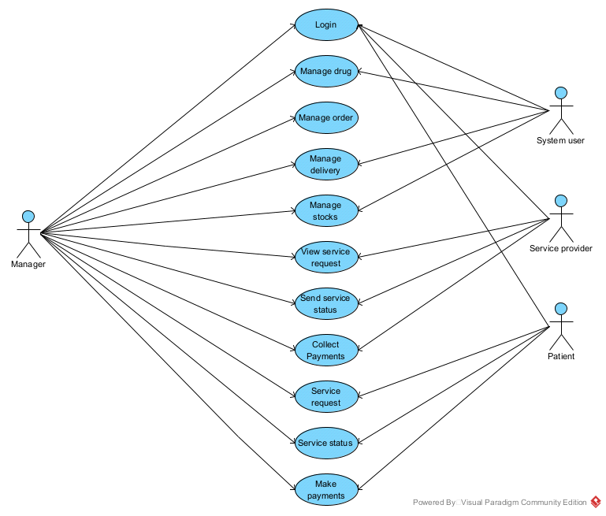

**System user:**

System user is a sub manager under main manager. we can also save that he/she a manager complete system or it can be a programmer that manager complete system functionality.

**Service provider:**

There is a person that that offer services to patients. He/she also get sending request from patient and send service status mean request accept or reject.

* **View service request:** This service request show to patient side and also show it viewed or not. This is request from stock maintainer or pharmacist. There is two types of service request. If order of drug which mean for production to produce more drug and second is return medicine with description. Side effect or not demanding in market.
* **Send service status:** When request is received then as response production send service status mean request accepted or rejected. If request rejected then explain why that request rejected with solid reason.
* **Collect payments:** There is provide a UI between patient and manager. It software that manage bank accounts and also show the statements. Patient side it shows only that patient statements mean patient paid or not his expenses. Manager side software shows all patient statements.

**Patient:**

Patient is a main person for that system created. all services provide to patient, if we not care about patient then system not work.

* **Make payments:** There is provide a UI between patient and manager. it software that manage bank accounts and also show the statements. patient side it show only that patient statements mean patient paid or not his expenses. Manager side software shows all patient statements.

**Hospital drug management system**

This is main system of Hospital Drug Management system. There we manage drug in hospital. Pharmacy is use to manage drug in hospital. There is patient physically appear in hospital and get appointment. When reach time of appointment doctor attend that patient. After attend patient doctor prescribe medicine for patient. Patient gets medicine from pharmacy. Pharmacy is also a sub-system that is managing drugs and linking it with stock management system. If pharmacist is out of stock he/she will contact the production area to refill his stock accordingly.

**Manager:**

Manager is a leader that manage or control complete system and responsible of complete work. He/she take decisions and start working of those decisions. He/she decide that Witch Company provides medicine to patient or pharmacy. He/she also consider price and effect of drug. He/she also provide detail or report to the system admin or owner. Manage workers and hire. Check workers work properly or not and also suspend workers and staff that not perform well. Manager provide interface between owner and system.

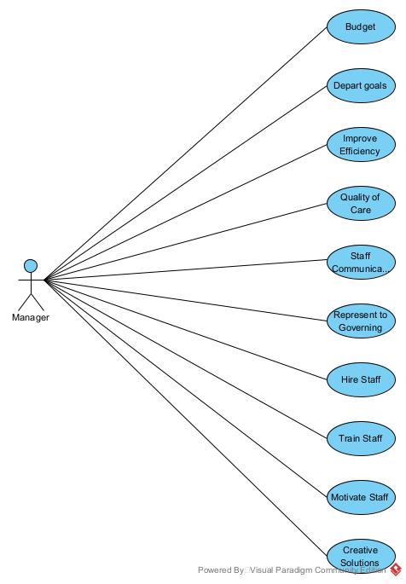

**Receptionist:**

The day to day of a medical receptionist is busy. Between scheduling new appointments, greeting patients and filling out patient forms, taking and delivering messages, they have to fit in ordering medical equipment, daily contact with nurse and doctors, the list goes on. Essentially, the receptionist is responsible for the smooth running of the entire hospital. They are the touchstone between doctors, nurses, staff, and patients. Below is a list of just some of the day-to-day tasks of a medical receptionist.

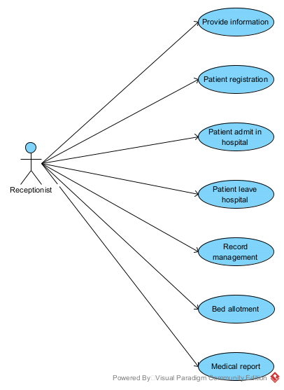

* **Provide information:** Receptionist provides information to every visitor if he/she patient, doctor and any one that want public information.
* **Patient registration:** Receptionist gets information from patient and store in Database or paper.
* **Patient admits in hospital:** If necessary to patient admit in hospital then it provide information how to admit or that provide place or bed for admit in hospital.
* **Patient leave hospital:** When doctor allow patient to go home then final statement check and tell the patient that you can go home.
* **Record management System:** There is stored all records of hospital with dates. Patient records, doctors records, worker records and patient records. There store many reports.
* **Bed allotment:** Receptionist provide information which bed is free and how you can get to that bed
* **Medical report:** If anyone not know that what doing next after report then receptionist provide information.

**Staff manager:**

There is staff management in hospital. Hospital staff is doctors, nurses, workers. There is also a person hire to manage hospital staff mean sett time table for doctors, nurses and workers. There is managing all persons that work in hospital.

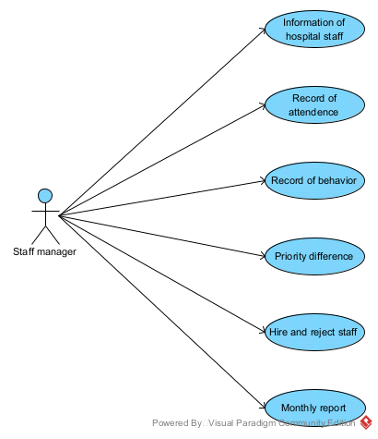

* **Information of hospital staff:** Staff manager have all information of hospital staff mean workers, nurses and so on. There is name, work, contact information.
* **Record of attendance:** There is record of attendance mean all staff attendance. How much get leave and absence and so on.
* **Record of behavior:** There is record all behaviors of staff mean how much behave good, better, normal and bad behave.
* **Priority difference:** There is priority differences and different requirements and have complete record of priority.
* **Hire and reject staff:** Manger can hire and reject staff about any reason because manager is control complete staff.
* **Monthly report:** Generate a report of every member of staff.

**Doctor’s management:**

There is complete sub system that manages doctors. There is also a doctor that manages doctors and doctor is main entity in hospital. Without doctor Hospital cannot work.

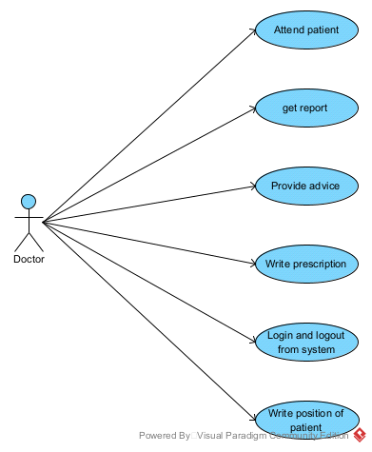

* **Attend patient:** Doctor attend patients on provided time or appointment. Check patients, identify disease.
* **Get report:** Get and see reports and identify disease.
* **Provide advice:** Provide advice and suggest food.
* **Write prescription:** After everything doctor write prescription.

**Finance manager:**

There is managing all amounts that rotate for hospital. There is also a sub system that control hospital finance. There manage patient payment, doctors salaries, staff salaries, drug price that get from company, return medicines and so on.

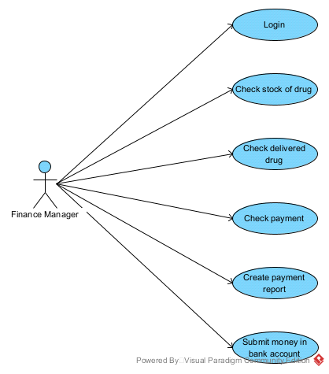

* **Check stock of drug:** there we countdown drugs how much drugs in stock. How much demand and payments for those drugs. If
* **Check delivered drug:** check delivered drugs and also check pending payments and clearance payments.
* **Check payment:** check all payments and also inform those buyers that cross limit of clearance
* **Create payment report:** There is develop a report of monthly payments.
* **Submit money in bank account**

**Record manager:**

There is stored all records of hospital with dates. Patient records, doctors records, worker records and patient records. There store many reports.

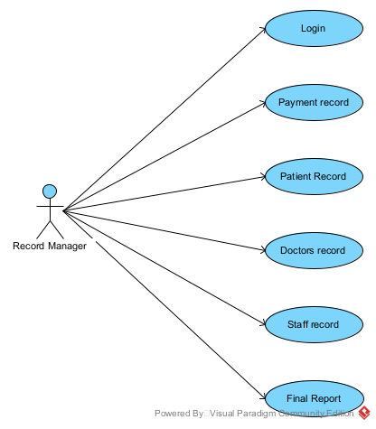

* **Payment record:** There is every month record of payments. Profit and loss and also pending payments.
* **Patient record:** There is all record of patients individually. There are files of records that is very important of finding of any patients.
* **Doctors record:** There is all record of doctors individually. There are file of records that is very important of finding of any doctors.
* **Staff record:** There is all record of staff individually. There are file of records that is very important of finding of any staff member.
* **Final report:** There is final report that develops on per month. That report develop for manager for check complete system.

**Information Manager:**

Every hospital has information system. There is a sub system that provides information. Every organization has different types of information. In hospital information provided about doctors, nurses, staff, treatment types, progress of hospital and so on.

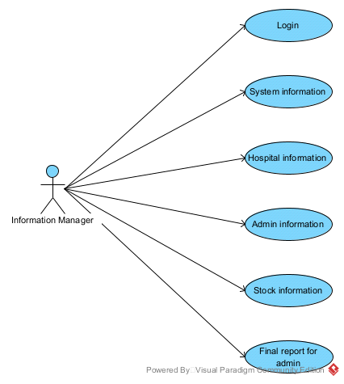

* **System information:** There is some system information that is different accessibility. For example finance information only accessible for finance manager. Same relevant person can access some specific information.
* **Hospital information:** There is physical information of hospital. There is some information is private and some public information.
* **Admin information:** Some information only setup for admin for example monthly reports only for admin.
* **Stock information:** There is information for stock manger that balance drug demand and supply.
* **Final report for admin:** Every sub-system has monthly final report. Final report sends to the owner.

**Drug management system in stock**

This is also a sub system that controls the demand and supply of drug. There is stock maintainer that maintains all stocks and maintains orders and delivery of drug. When demand increase of any drug it inform to the production to produce more drug and also inform when decrease the demand of medicine to decrease the production of that medicine. There is accountant that produces results or final reports.

**Stock maintainer:**

Stock maintainer is a person mainly that is manager of stock. He/she have connection between production and pharmacies and patients. All drugs after preparation save in stock. All information about supply and demand provided there.

* **Add company:** Stock maintainer have list of companies where drug receive and have contacts with pharmacies and hospitals for providing medicine
* **Add stock:** Receive or get stock from pharmacist companies. Save in stock for selling to pharmacy.
* **Sell stock:** Stock sell to the patients, pharmacies and hospitals.
* **Make payment:** There is mainly collect payments and estimate profit and loss.

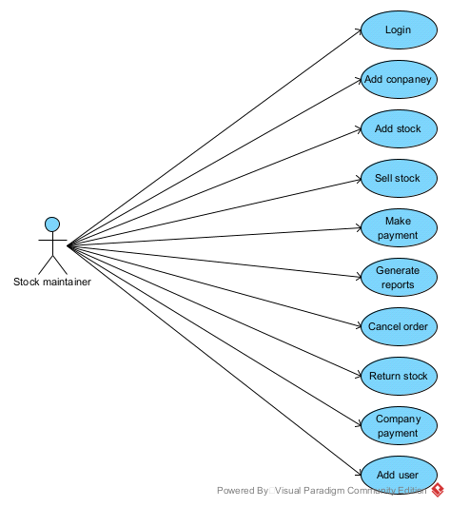

* **Generate reports:** There is generate reports about all stock and payments and pending payments for clearance.
* **Cancel order:** When an order placed and it can be possible to cancel that order. If medicine not sold then pharmacy owner can cancel order that place for more medicine.
* **Return stack:** Some time medicine not sold then it will be return that medicine to the stock and then stock maintainer return payment to the pharmacy owner.
* **Company payment:** Company payments are different. Some companies have rules to pay when you get medicine and some have to pay when medicine sold from stock.
* **Add user:** Stock maintainer is owner of stock and it can be change and add users and workers.

**Sequence diagram**

**Patient:**

That system develop for patient first patient login to the system and join the system then patient can access system and resources.

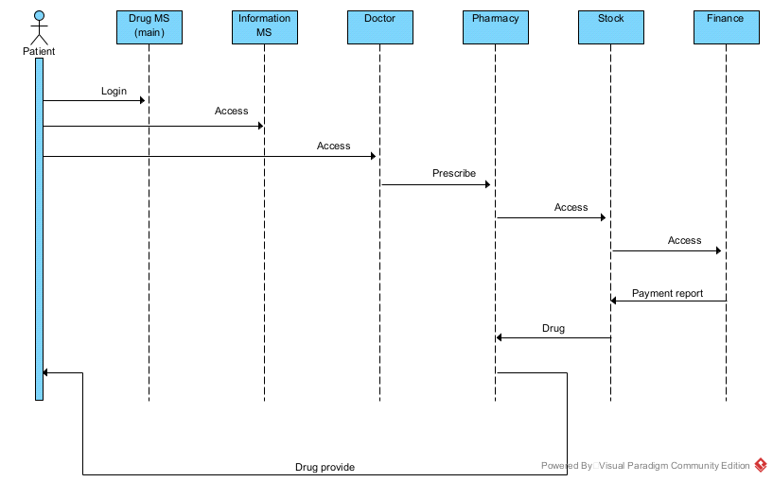

* First patient login to the system there we authenticate and verify user information mean name, email and password. We send verification link to the user email and verify user.
* After login we provide information to the patient about system and services. When user gets any relevant information then move next.
* Apply for appointment and get relevant doctor. Doctor prescribes medicine and provides advice.
* Patient will go to the pharmacy and provide doctor prescription and get medicine.
* Pharmacist checks medicine in stock and provide medicine.
* Pharmacist provides medicine and provide bill and get payment.

**Manager:**

Manager is system admin that access almost complete system. Manager login to system and have some specific information that tell the system about that is manager it can be an ID or an email or any think else it depends on developer.

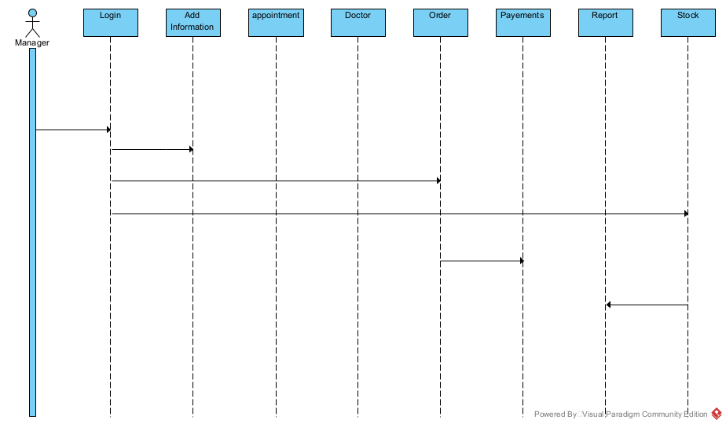

* First manager login to the system and provide relevant information.
* Manager adds information for patient. Patient can read that information and information can be a service or system information.
* Manager is decide about appointment system and patient say for appointment and manager set time or fixes some rules for appointments.
* Inform doctor about appointment time.
* There is also an order system for drug patient order medicine online and report to manager about that order.
* There is two types of payments system one is online and other is physical. If patient appear physically in hospital then use physical payment system. Otherwise it uses online payment system that is stripe payment system.
* Provide medicine from stock and create final report that store in database.

**Activity diagram**

Activity diagram show our system activities. There are main actors involved and perform specific tasks.

Patient and admin are main actors in system because admin that is create that system mean investor and that system create for patient.

Diagnostic, doctor, pharmacy and stock are workers we can say that without these system can’t work.

Admin is main person that access system to check all system for example when he/she enter in system then he/she access reports and functionalities of systems. When admin enter in system, system can’t inform anyone about admin.

Anyone login in system then system will verify that person is authorize or not. If not authorized person want to access system, system will block that user.

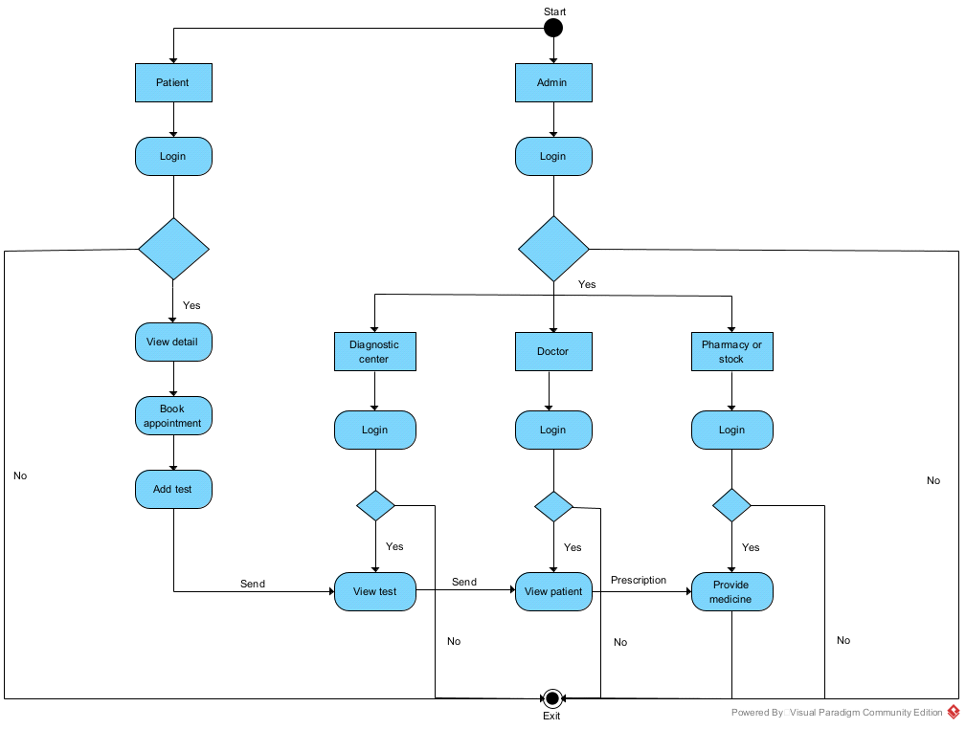

Patient login and view detail or we say view information. Apply for appointment and system have to code to setup appointment time for patient. If patient have test reports then patient provide that reports. All detail send to the diagnostic center. Pass all detail to doctor and doctor see all information and write prescription and send that to the pharmacist and that provide medicine to patient. Last functionality is exit from system.

**Class diagram**

Class diagram explain complete system in different classes and every class have some attribute and methods.

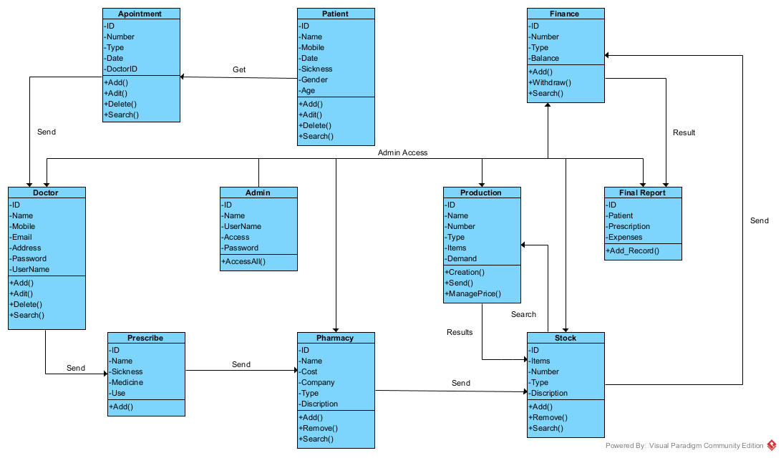

* **Patient:** Every patient has a specific id that is unique and created by system and that id unique for everyone that joins that system. Patient Name, gender, age, mobile, type of disease date when patient join system and doctor id that patient want to attend. There is some method. Patient can add in system, edit information by patient, delete any information that relevant to the patient and search information from system
* **Appointment:** It has unique ID, date, type of disease and doctor id. There is also some methods cancel appointment, apply for appointment and so on.
* **Doctor:** doctor has unique ID, name, mobile, email, address, password (private), username for accessing doctors in system. There are also some methods like CURD operation for doctor.
* **Admin:** Admin has unique id, name, user name, access that is allowed by system when system verify to admin. Only one method apply for that is access all pages or system and reports.
* **Production:** there is all detail about medicine prepared and sold and every order has unique ID and many more. There are some methods that are creation, send medicine and manage price.
* **Prescribe:** Prescription has unique id, disease, medicine name and how to use that medicine. There is only one method that is added.
* **Pharmacy:** Create a bill with cost, company and description. There are three methods that apply on pharmacy medicine that is added, remove and search.
* **Stock:** Every medicine stock is unique id, item, number, type and description and there are some methods that are add remove and search for medicine.
* **Finance:** Finance is payment system that uses to pay for medicine there are some attribute and methods for payment.
* **Final Report:** when a patient complete everything and get medicine then finally create a final report that saves in database.

**State diagram**

There is state of application mean every functionality have different states. There are some states of work.

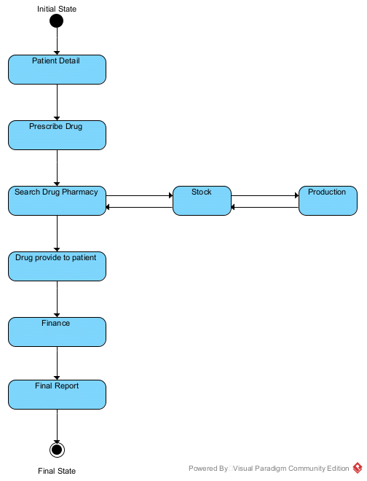

* Initial state: It is first state where start is working. When a patient open application there is initial state.
* Prescribe drug: There is second state where start is to find disease and prescribe drug for patient. Provide prescription to the pharmacist.
* Search drug: Pharmacist find that drug. If not have drug in pharmacy then pharmacist contact with stock to find that drug.
* Stock: If drug not have in pharmacy then find in stock. If not have pharmacy then it contact with production to produce drug.
* Production: production will produce medicine if stock manger order to produce drug because it increase demand.
* Drug Provide to patient: When find drug then provide that drug to patient
* Finance: patient get drug and pay for that drug to finance.
* Final Report: There is write final report and every patient has individual final report.
* Final State: It can be a logout form system or leave system.

**Code**

**Client Side Register Page:**

Register page frontend part that get user information and send it to server. There are three input fields that are getting user information.

Information passes to a state. React provide a hook that is use State that handle any type

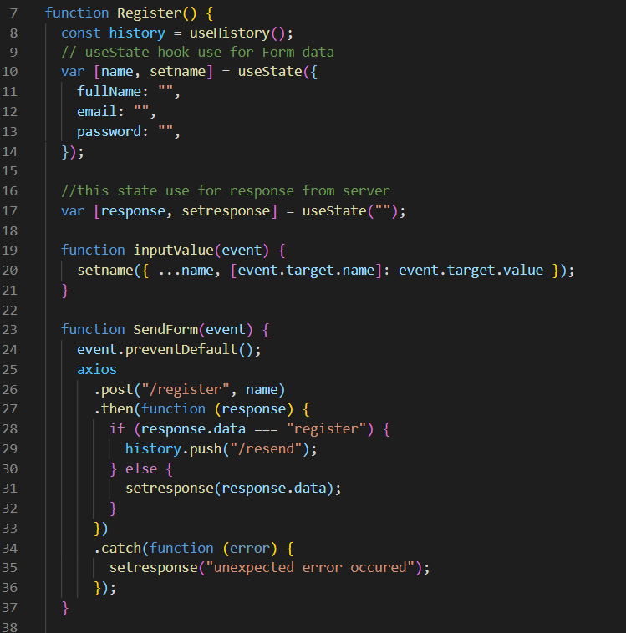

Of information. There are three parts of state.

* **Initial State:** there is value that start state it can be a one value or object. About state initial state is an object and have fullName that handle user name, email that handle user email and password that handle user password.
* **Current state:** current state when callback provide a value that is that handle initial to current value and replace initial value.
* **Callback:** Callback is a function that use to get state current value and then we access that value from current state.

There is function inputValue that get user data and set in state. This function execute onChange event that is in input field. Every changing in input field execute that function and send values to “inputValues” function. There is another function “sendForm” it trigger when form submit and user click submit button there is a onClick event that use to trigger a function when user click on button. It is use to send form data to server for further processing.

We use axios for send data to server it is a npm package that provide some predefine functions.

We use axios.post() function for sending user data client to server. That return some promises so we can use both async or sync for processing or sending or receiving information. there is two types of post function arguments one is url and second is data. Server send some responses that receive in then() and errors receive in catch() and both provided with post and get.

**Client Side Register Page:**

There is we get user information that save in database and display it on page. Profile have two parts one is getting data from server and display it on page and second is change profile image mean user can update his profile image. There is three types of hooks one is useStae that explain earlier in detail. Second is useHistory that is provided in “react-router-dom” package that use to develop a routing system. It have main functionality that is switch pages without loading web application so it is very fast and secure. Use history hook trigger page path without loading whole application.

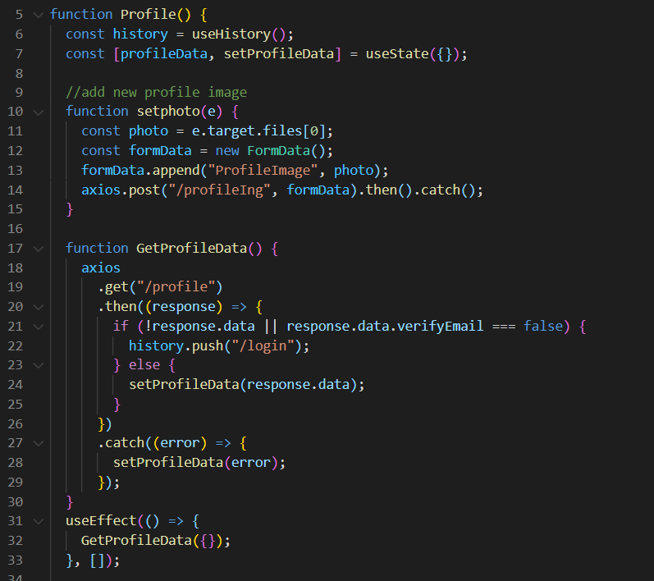

There is use axios.get() function that get data from server and save in state and then display it on page for user mean user can see it. When page is trigger only one time execute “GetProfileData” function data. There is a hook that is useEffect when we use and call a function with that hook it execute only one time. When page load function trigger and get data from server and display it on page. There is also a authentication when we don`t receive user information from server mean user not register not register in our system then switch user to login page and say first login to system and then you can access profile page.

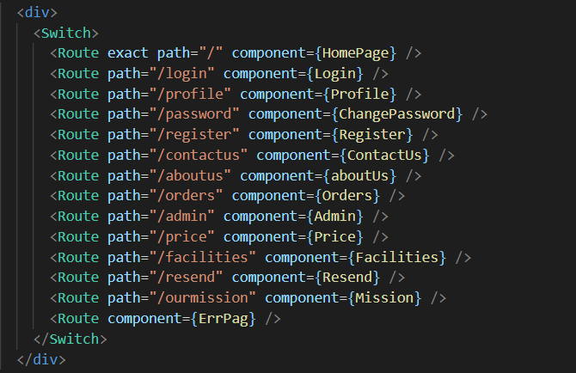

**Client Side Routing:**

There is routing and some predefine modules that provided by “react-router-dom ” package Route is a package that use to setup routing there are two properties one is path and second is component. In path we provide path that is show new page and in component provide a module that is triggered. Last is error page if any path that provided by user not exist in our application then it show error page.

**Client Side Toggling:**

This functionality provided for toggling mean when user login our system then hide login and register page and show profile page there is profile image of your and show “You” with image. there is also same functionality.

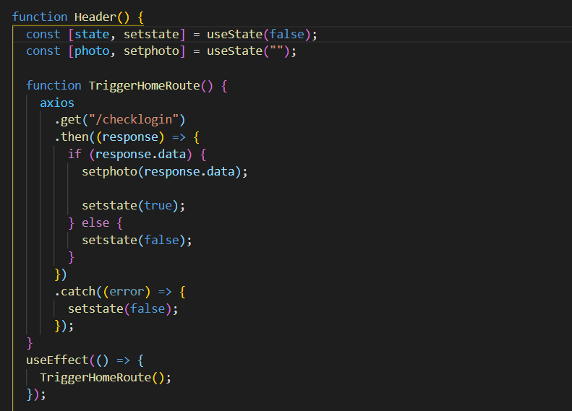

When page load it call a function that send request to server and check user login or not if user login server response and state change as true.

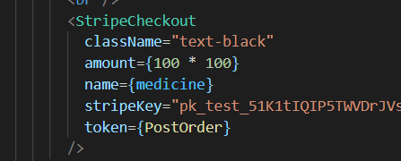

**Backend**

**Server Side Handle Profile Image:**

Receive profile image server side that send from client side and save image path in database. We use JWT token for accessing user information and save path of image of relevant user. There is patient.findOne() function that use for mongodb database.

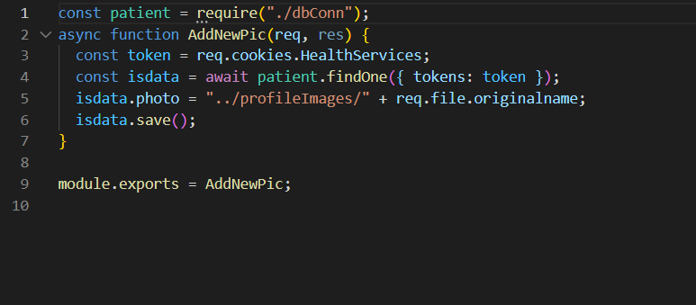

**Server Side Logout:**

There is apply logout system it is very simple just send a request for data from database and remove token from database.

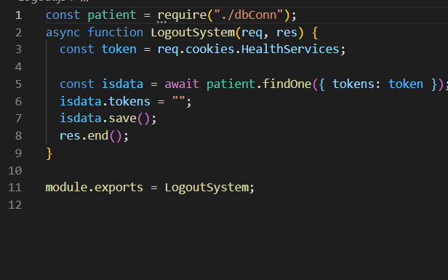

**Server Side Email Verification:**

There is we fix url when that url trigger it fetch token from url and find that token in database if token is match then token change to null of database and there is emailVerify variable its type is Boolean. By default emailVerify is false but when we match token we change it to true mean account activated and save in database.

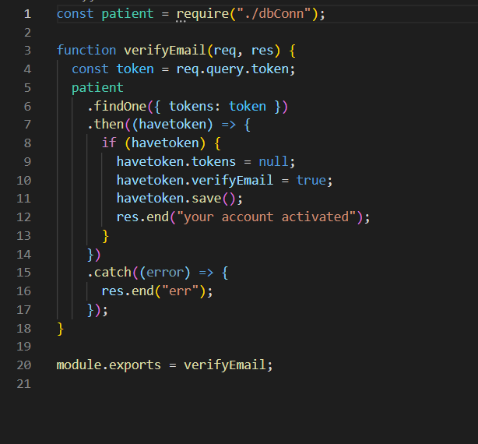

**Server Side Mongodb:**

There is database connection. We use mongoose for handling mongodb database. First install mongoose npm package and second we require it where we want to use. First step we create connection to database. There is two types of mongodb database one is online and other is local. Mostly we use local for development process. Mongoose provide predefine function for connection that is mongoose.connect(url).then().catch(). It is promise base function if successfully connected with database call then() function and if not connected(connection error) with database it call catch() function.

After that we create schema of database. Schema is a structure of database mean how values save in database and types of variables.

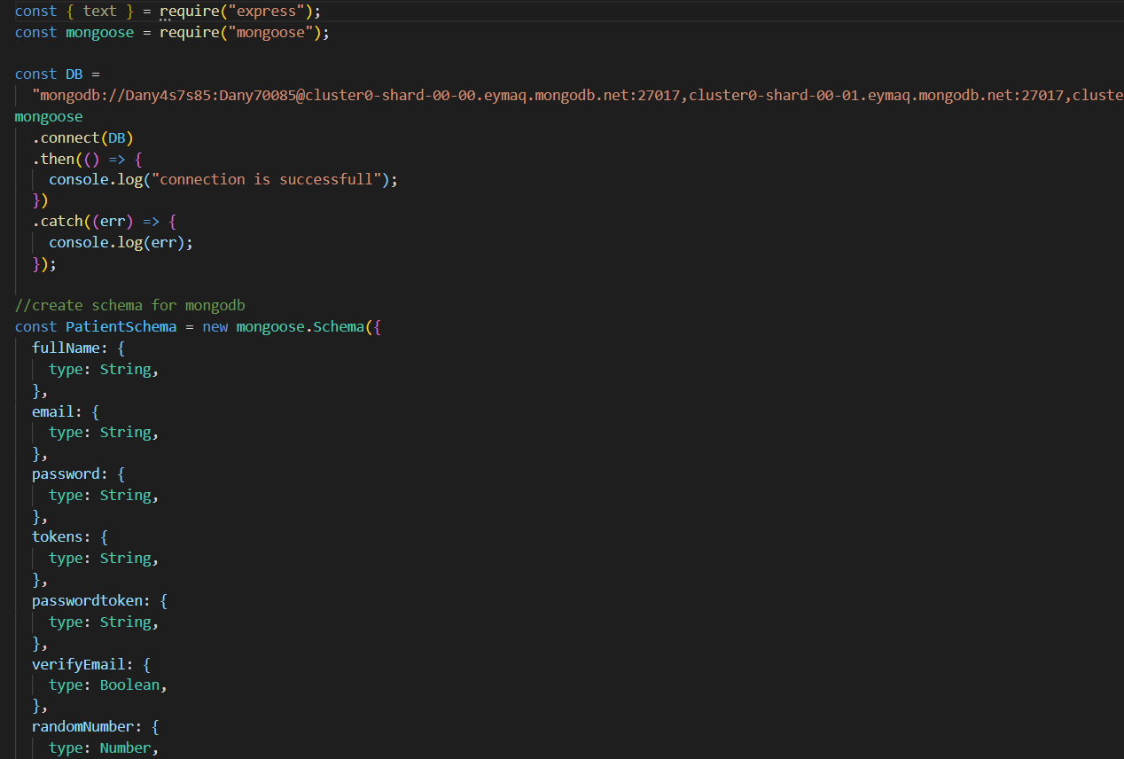

**Server Side checking login:**

There is simple check user is login or not. It is very simple just we receive a request from client side and match token if token is match then check account activated or not. If account activated then se send image path to client side to show profile of user.

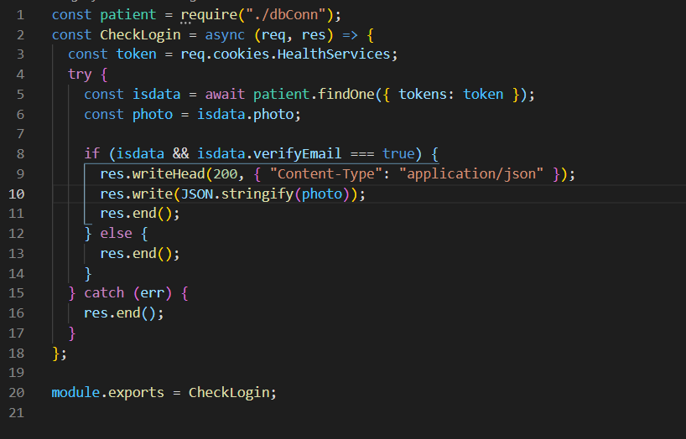

**Server Side Register User:**

This page we register user in our system. First we receive user data from client side. There is many authentication and verification of data. First we check all data and no any field is blank if any field blank we send response to user “all fields required”.

Second we validate email if user not provide a valid email then we send message to user “use a valid email”.

Third we check email in database if email already exist in database then send response to server that “Email already exist use another one”.

After that we save data in database.

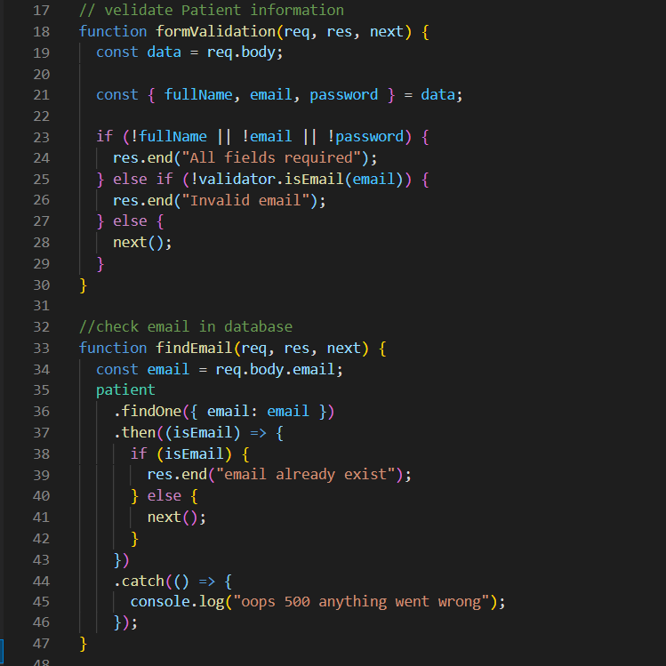

There we first create jwt token jwt token we install a library from npm and require in server side and create a token that is use to jwt.sign() it is predefine function that use to create a token. It has two arguments. One is key that use with every token and other is any unique thing it can be Id or email or any other thing that is unique. I am using email as a unique thing. There are some other arguments that is expire token etc.

After saving data in database there is other functionality that is cookie parser. It save token in browser to authenticate user and also user not login every time when he reach our web application. It has two arguments one is name of cookie and other is token.

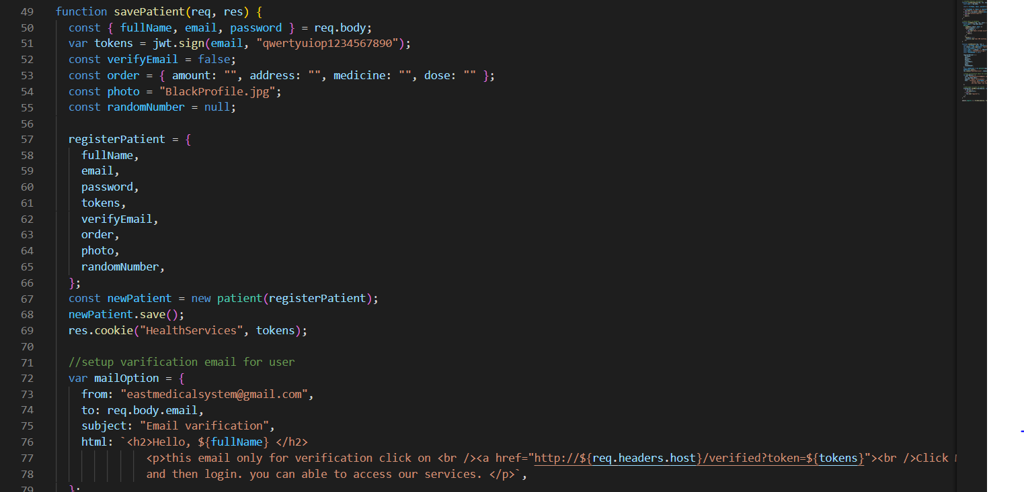

On register page I am using nodemailer for send mail to user for verify user information. it is npm package we install and require it and then use for send mail from system. First we use nodemailer.createTransport() there is two arguments. One is “service” authenticate service. Second is auth it have two part user (provide email) and pass (provide password). Now we setup email that is sender from our system

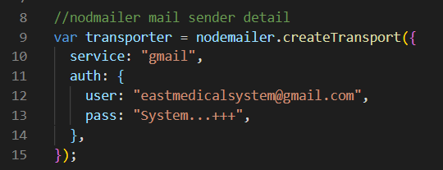

There is setup sender and receiver of email this is same when send email from email box but it not well structure in look. In html we write same html tag to send email.

Second is transporter that sends email. If have any error then it show error otherwise email send successfully. In mailerOption of html elements have <a> tag with tokens and that token we receive and activate account.

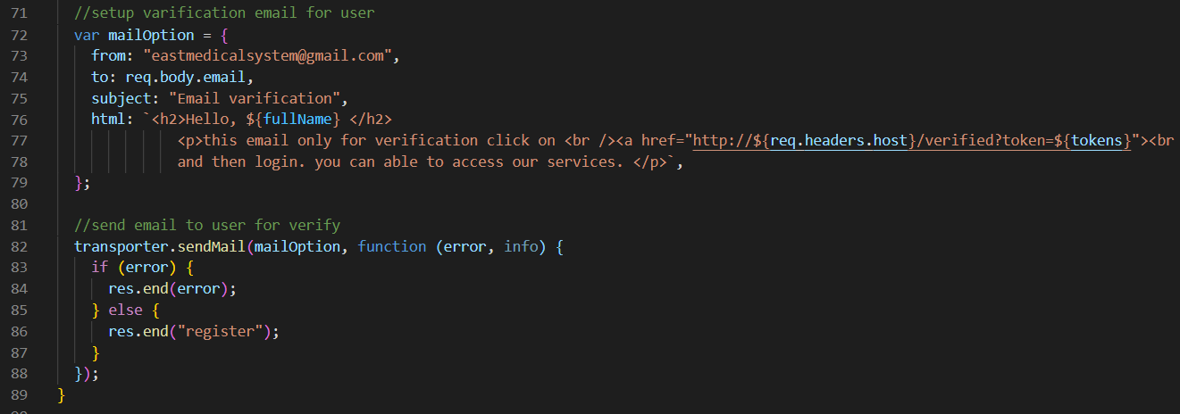

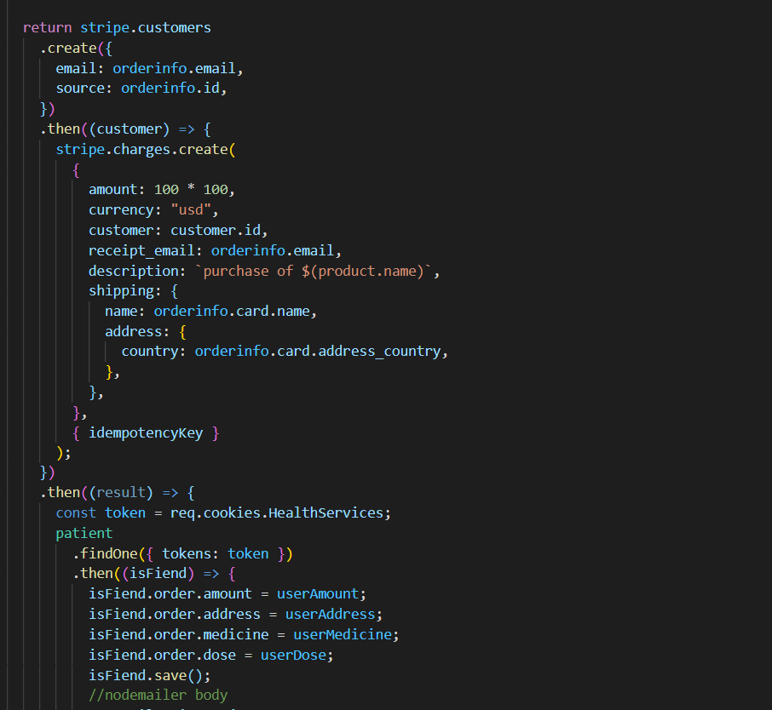

**Testing**/**Results**

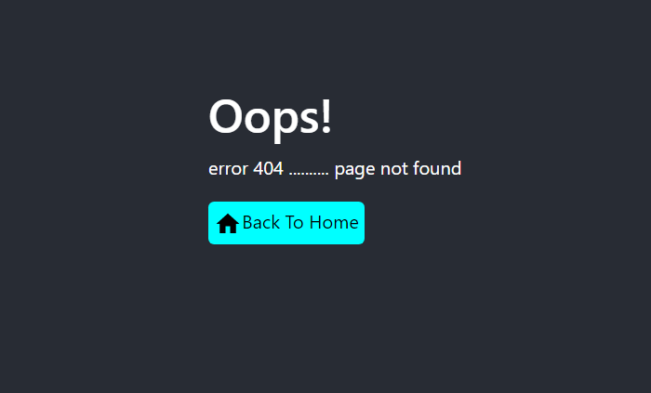

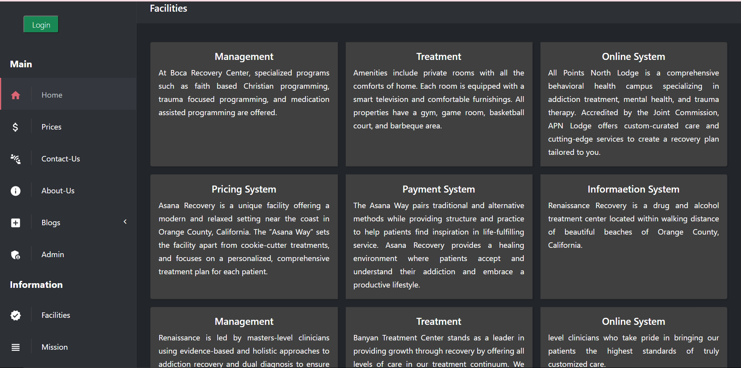

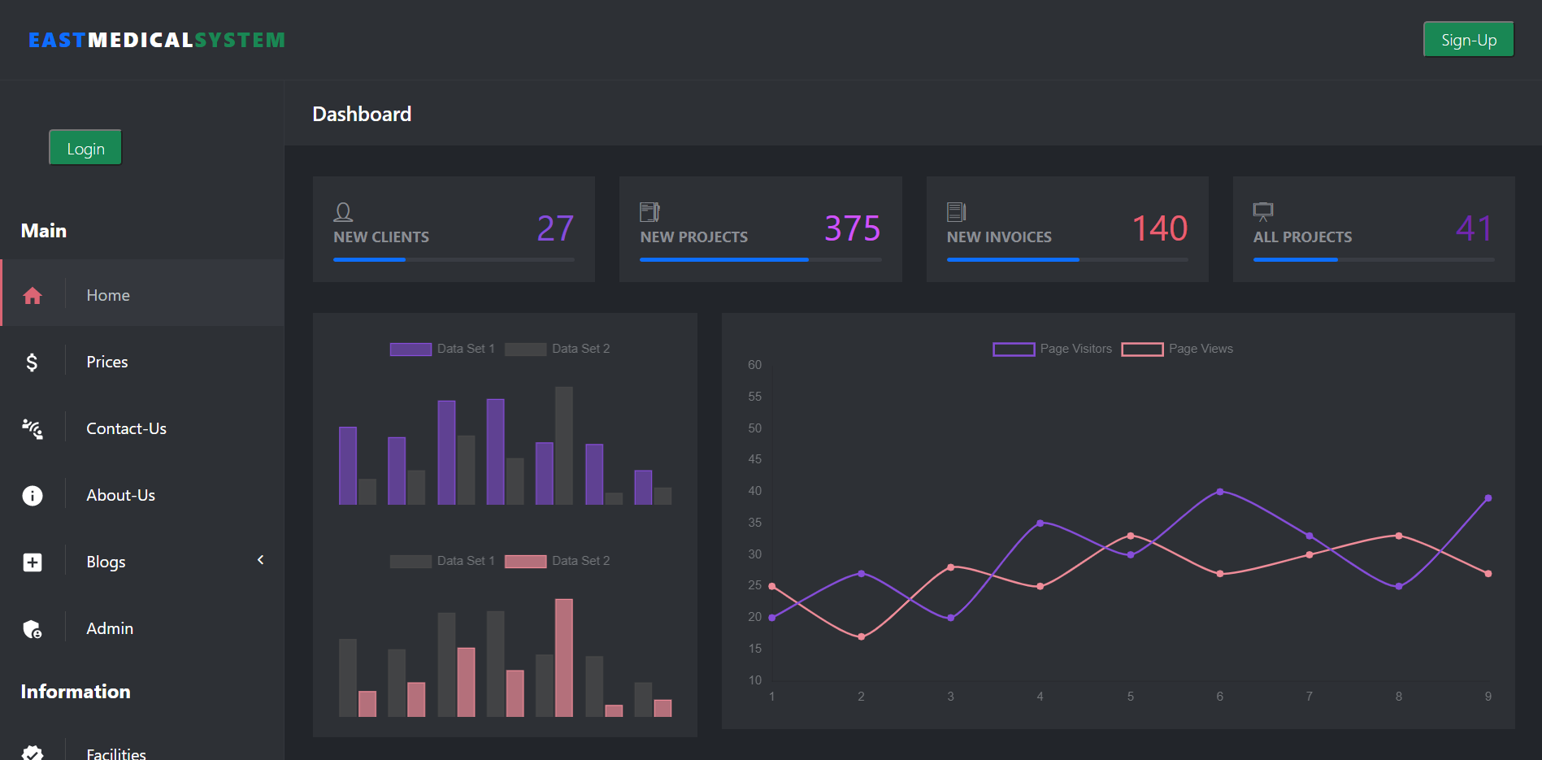

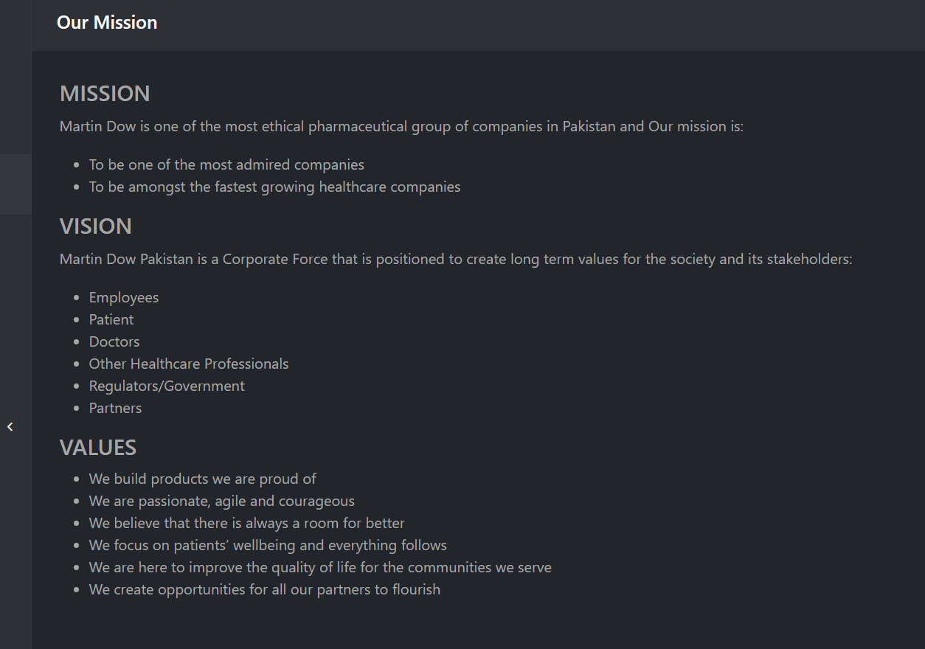

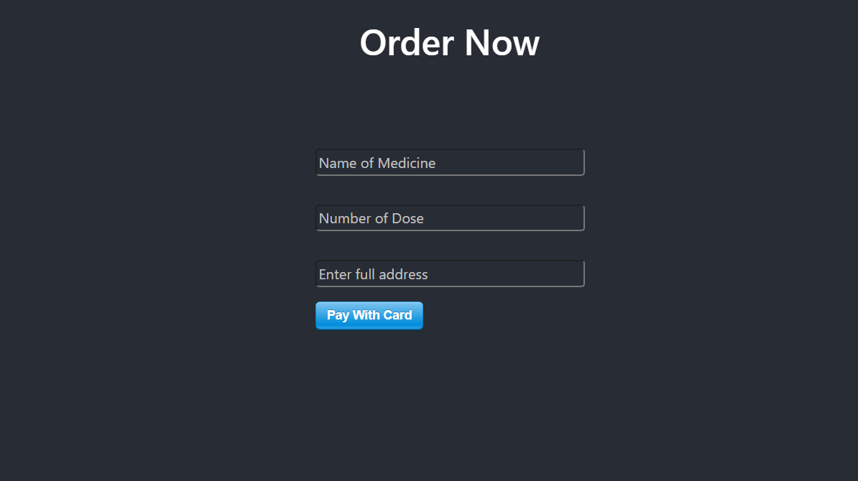

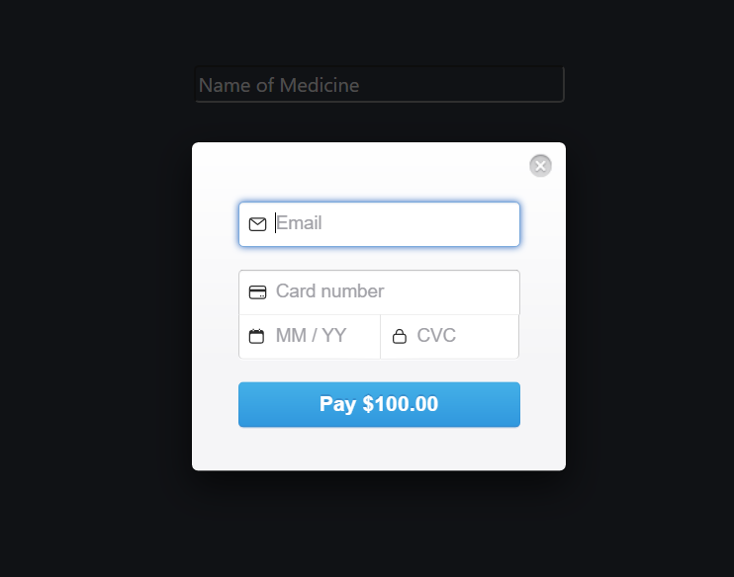

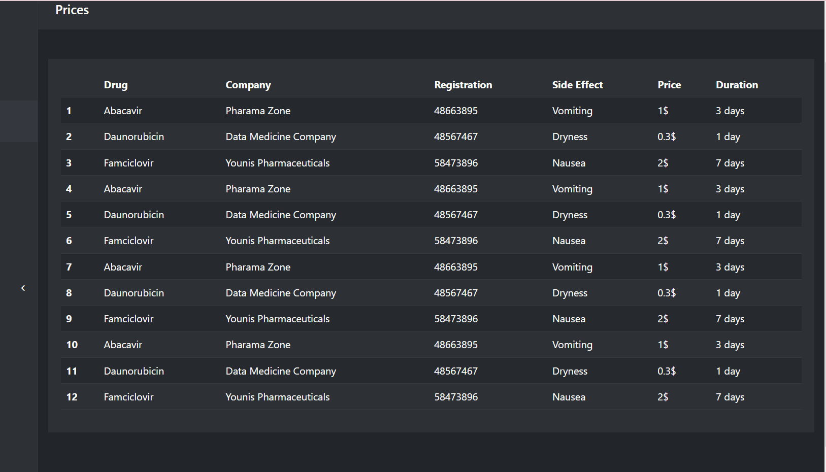

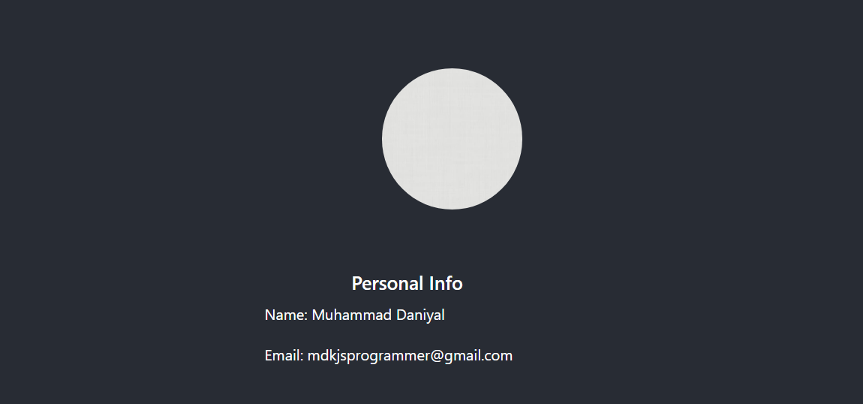

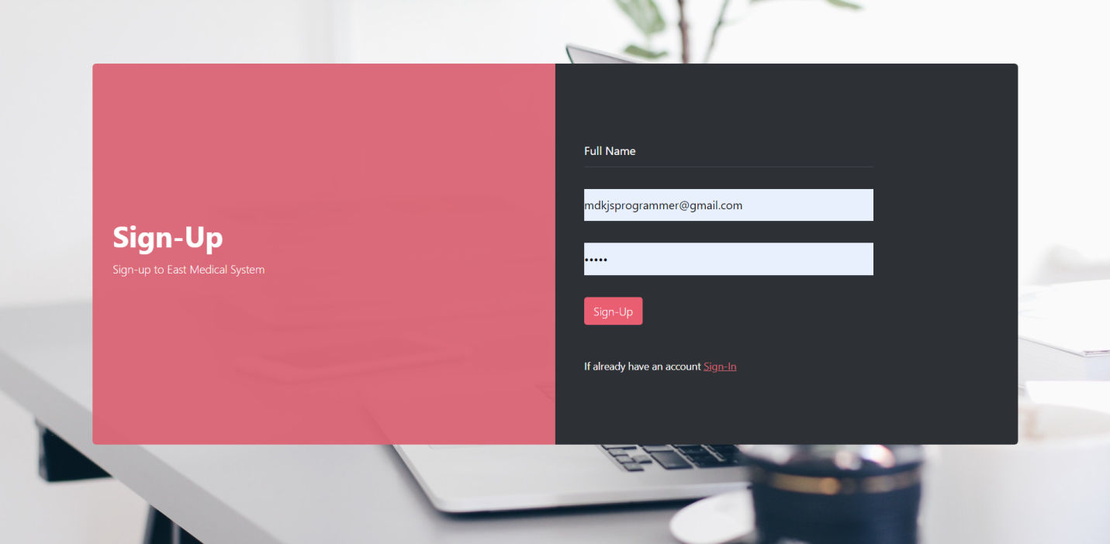

**Conclusions**